CS 255 System Design Document

UML Diagrams

UML Use Case Diagram

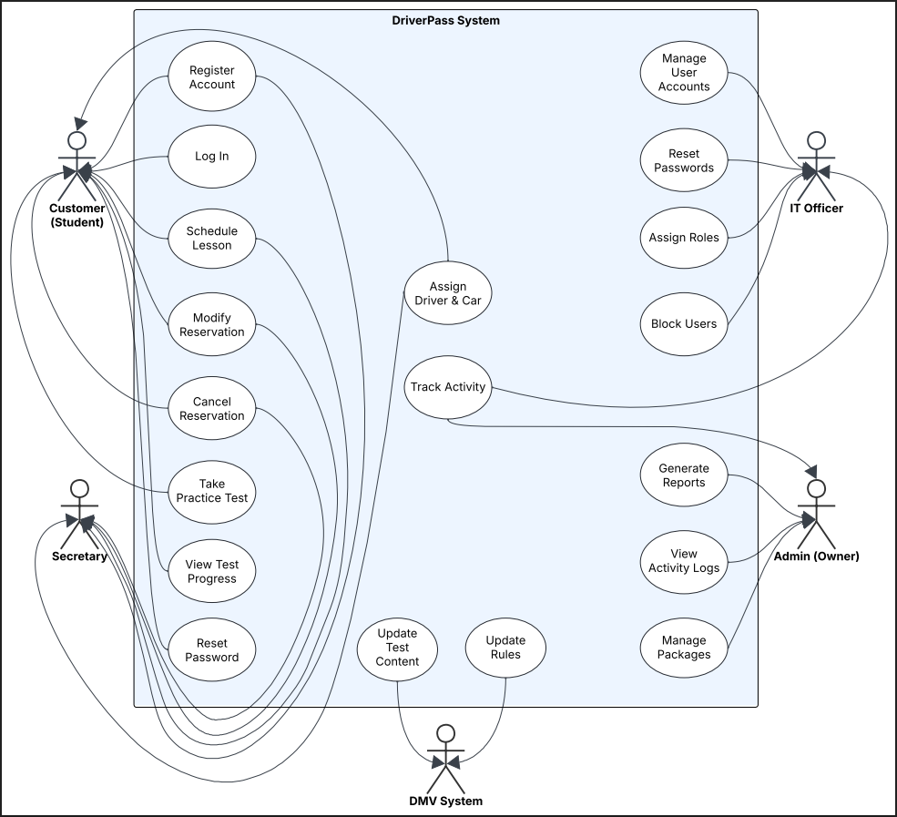
Figure 1: DriverPass System Use Case Diagram

UML Activity Diagrams

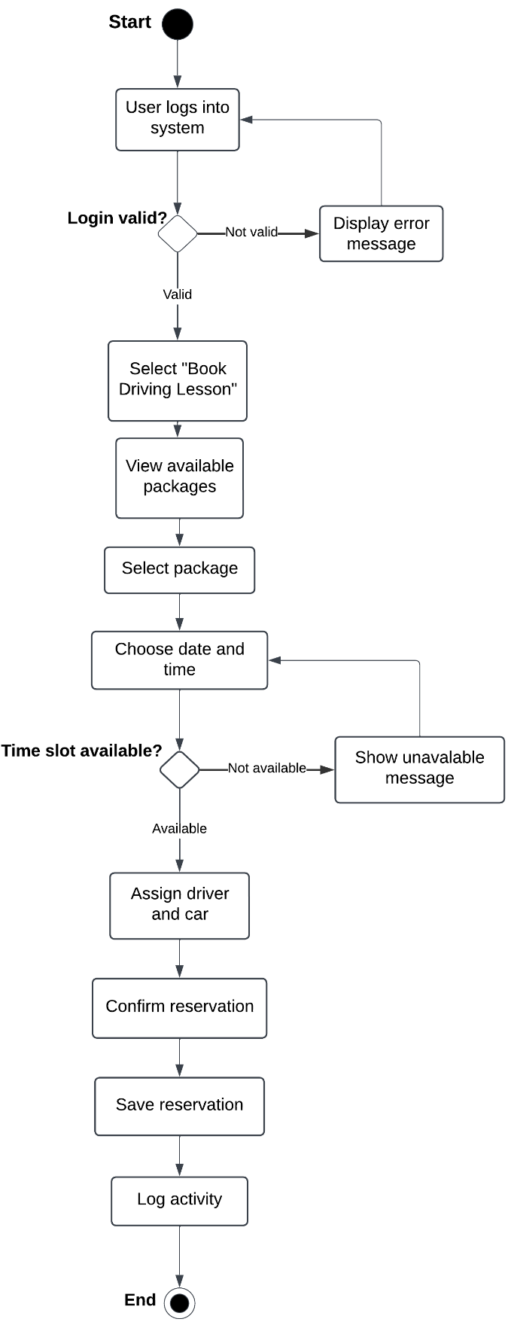
Figure 2: User Login and Reservation Activity Diagram

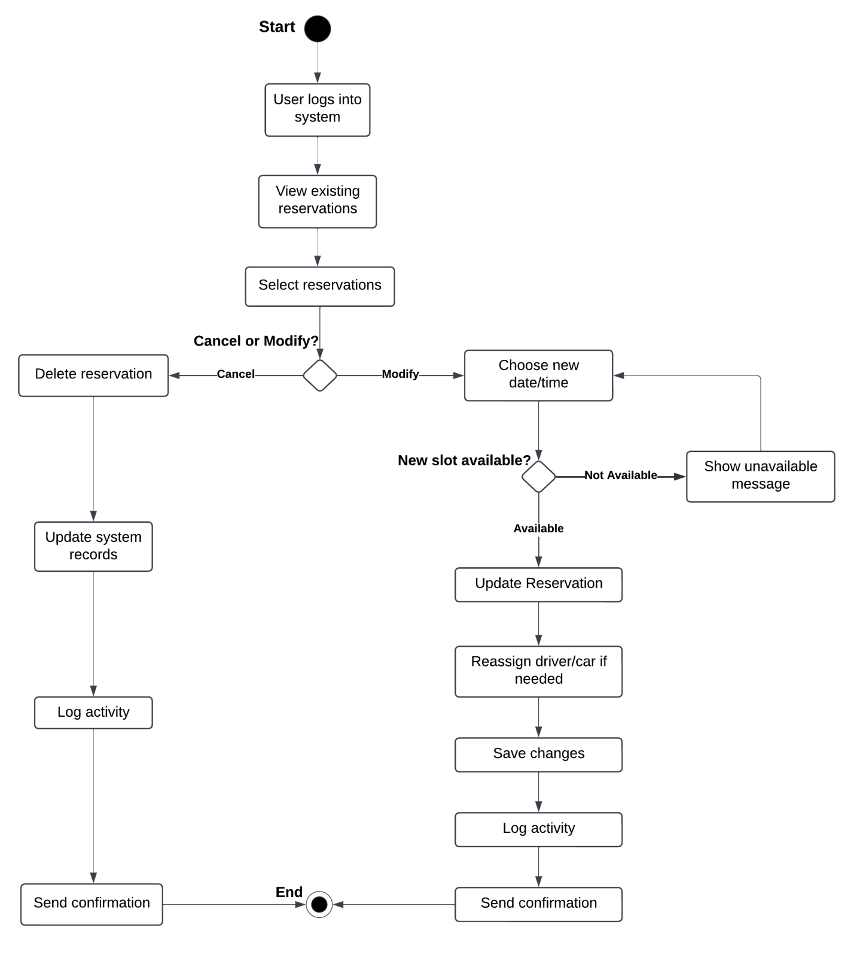
Figure 3: Driving Lesson Reservation Activity Diagram

UML Sequence Diagram

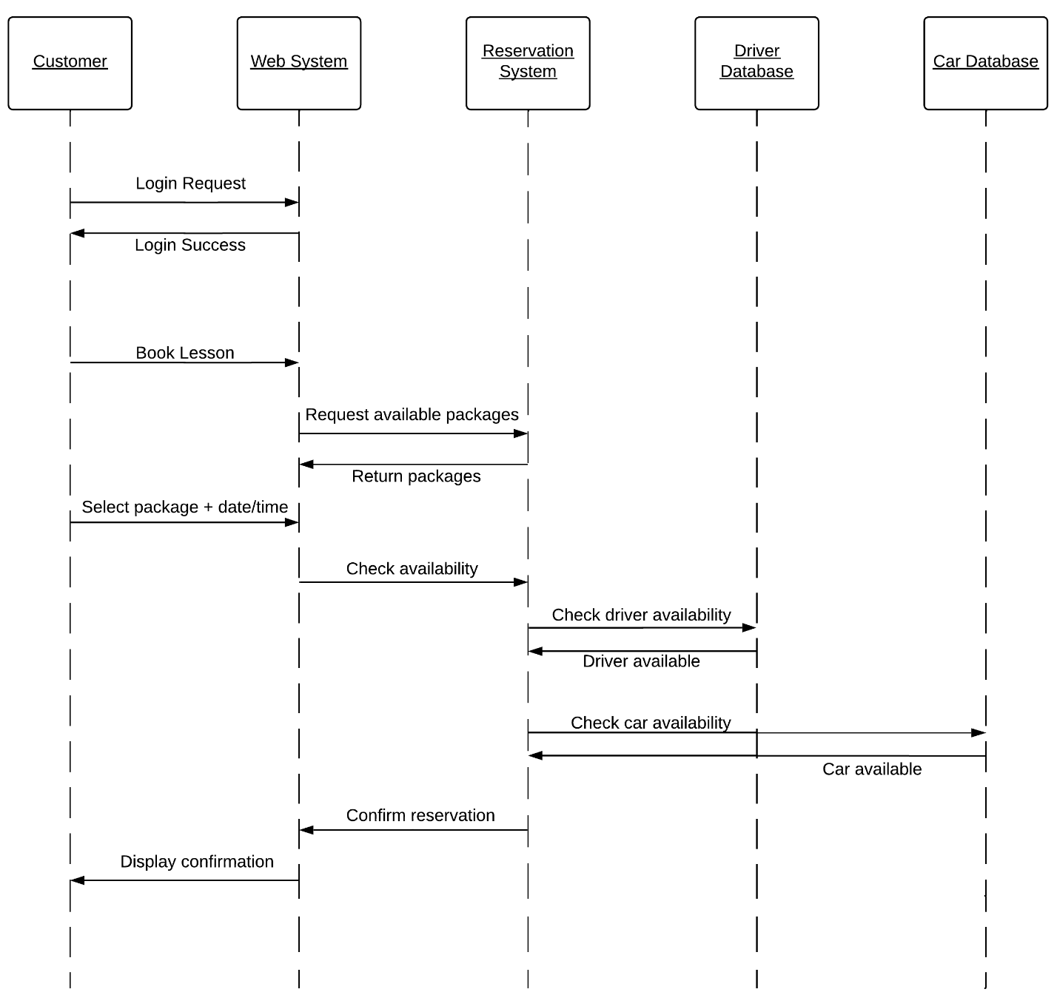

Figure 4: Reservation Scheduling Sequence Diagram

UML Class Diagram

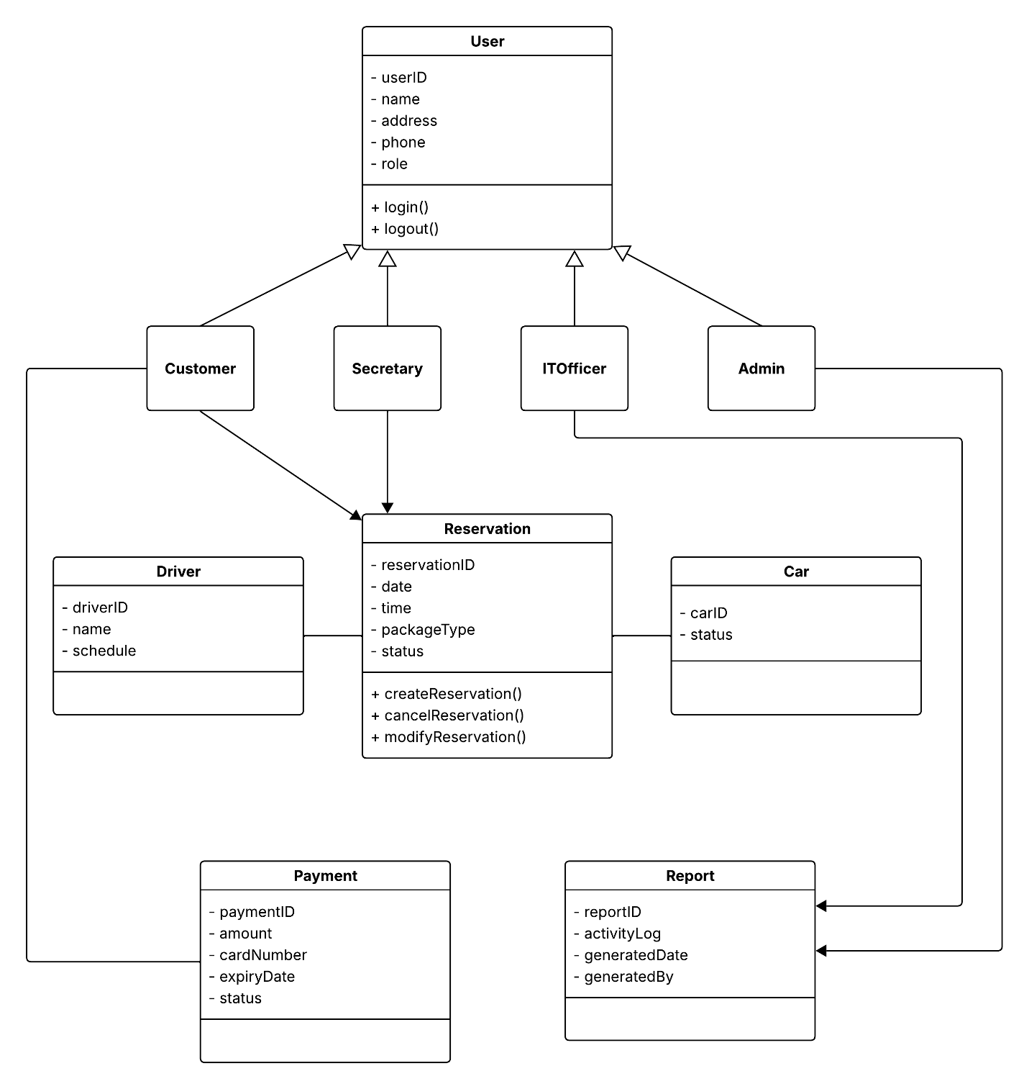
Figure 5: DriverPass System Class Diagram

Technical Requirements

The DriverPass system will provide users with a cloud-based application that they can access through any internet-connected device. The system will operate from a secure cloud environment which enables it to provide dependable service while growing its capacity and simplifying system upkeep.

Users need to use either desktop computers, laptops, tablets, or mobile phones that support modern web browsers to meet the hardware requirements. The system will operate on cloud-based servers which a hosting provider controls.

The system requires users to access it through standard web browsers, which include Edge, Chrome and Firefox. The system will require a secure database management system to store user accounts, reservation payments, and system activity logs.

The system needs a stable internet connection because users must access features while receiving real-time updates. The system does not support offline data modification because it would lead to data inconsistencies.

The system will use role-based access control to limit user access to functions that match their respective roles, which include Customer, Secretary, IT Officer, and Admin. The system will implement additional security measures through encrypted data storage, secure login authentication, and password recovery functionality.

For data management requirements, the system will store and manage customer information, driving lesson reservations, assigned drivers and vehicles, payment records, and activity logs for auditing purposes.

Finally, for external integration requirements, the system will connect with DMV updates to ensure that training materials, rules, and practice tests remain current and accurate.

